North Carolina 4-H
Project Record Report Form
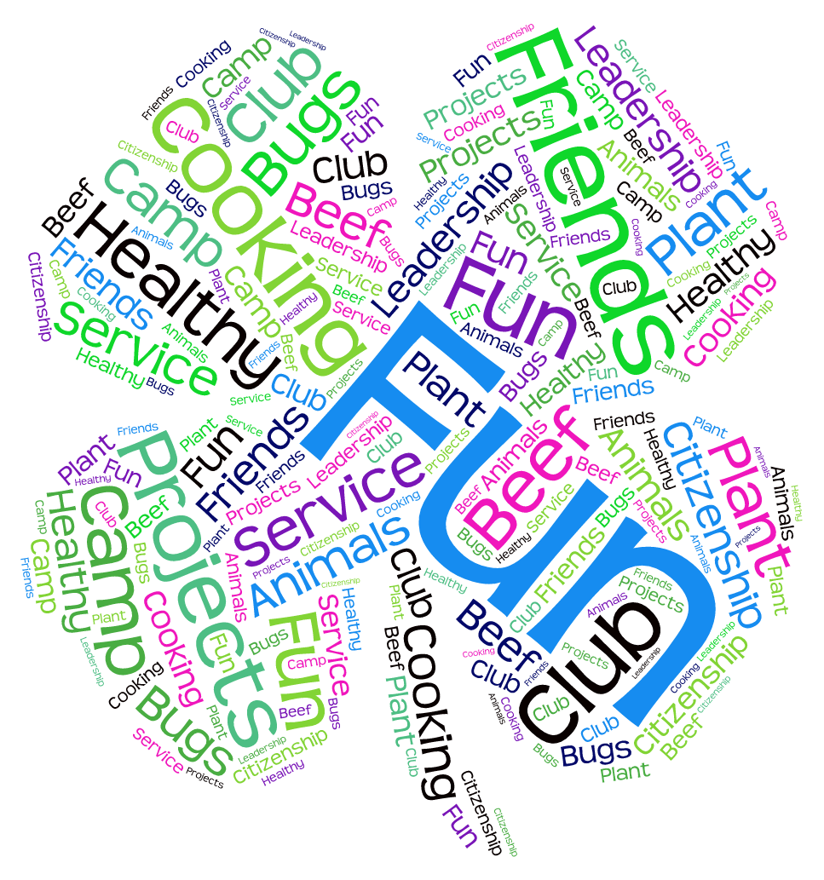
Age Categories:
9-10, 11-12
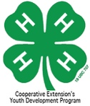
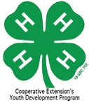
SECTION 1: Personal Information

County You Participate In 4-H: ______________ Program Year: _______

4-H Project Record Category in which you are entering: _________________________________

Competition Category: 9 thru 10 years old 11 thru 12 years old
(age as of Jan. 1 for the project reporting year)

Number of years in the above program area: _____ Years in 4-H: _____

Name: __________ __________ __________ Male Female
(first) (middle) (last)

Name you want used in publicity: ______________________________________
(please print)

Home Mailing Address: ______________________________________

City: ______________________ State: ________ Zip Code: __________

Primary Telephone Number (include area code): ______________________________________

Date and Year of Birth: __________ Age as of January 1: __________
(age as of Jan. 1 for the project reporting year)
Names of parents or guardians: _______________________________________________

Name of your 4-H club or group: _________________ 4-H’ers Primary email address if applicable: ______________

Name of School: __________________ Grade in School: __________________

Prior 4-H Project Record Gold awards won in this category Gold Year:
for this age group:

STATEMENT BY 4-H MEMBER

I give North Carolina 4-H permission to use my record as a sample, after identifying information has been removed, and allow North Carolina 4-H to use my Digital Media if any is provided to use for 4-H Marketing opportunities. I also understand that North Carolina 4-H will contact me before any of my information is shared.

I have personally prepared this report and certify that it accurately reflects my work:

Date: ____________, 20 ___________ Signature of 4-H Member: _____________________________________

APPROVAL OF THIS REPORT

We have reviewed this report and believe it to be correct:

Date: _______________, 20________ Signed: ____________________________________________________
(Parent or guardian)
Date: _______________, 20________ Signed: ____________________________________________________
(Local 4-H Leader)
Date: _______________, 20________ Signed: ____________________________________________________
(County Extension Agent)

4-H & YOU!
Answer questions on separate paper if needed.

Looking back over the past year in 4-H:

1. What was your favorite thing you did in 4-H this year and why?

2. Who is your role model in 4-H? Why?

3. What was the most important thing you have learned during the past year in 4-H?

Looking to the future:

4. If you were in charge of 4-H, how would you make it better? In your:

Club:

County:

District:

SECTION 2
My 4-H Story

Program Year:_____

SECTION 3
4-H Project Focus

What did you do in this project this year? | What did you learn? | Date

Did you spend or make any money on your project?
How much did you spend? How much did you make?

Program Year:_____
SECTION 4
Leadership/Citizenship/Community Service

Activity  L=Leadership, C=Citizenship, CS=Community Service | Accomplishment/hours | Level | Date

Program Year:_____

SECTION 5
Awards and Recognition
List all the awards, honors, and recognitions you have received including contests, trips, certificates, ribbons, etc. Specify whether they were National, Regional, State, District, County, or Club awards.

Experiences should be divided between project specific awards that related to this Project Record area, other 4-H awards and non-4-H awards. List your Project Record project specific awards first then follow with other awards and then non-4-H awards.

4-H Project Record Awards

Award/Recognition | For What Received | Date

Other 4-H Awards

Award/Recognition | For What Received | Date

Non 4-H Awards & Recognition

Type of Award | For What Received | Date

Program Year:_____
SECTION 6
4-H Photos and Supporting Materials

SECTION 7 Program Year:_____
4-H Goal Setting

What would you like to do next year in 4-H (after you submit this project)? On a separate piece of paper, please use the guide below to plan your 4-H goals for next year. Include goals for your entire 4-H year as well as goals for this specific project. There is no page limit to this section.

ACTION RESULTS TIMETABLE

For More Information

Visit our website: www.nc4h.org

Shannon B. McCollum, Ed.D
Extension 4-H Associate
shannon_mccollum@ncsu.edu
(919)515-8486

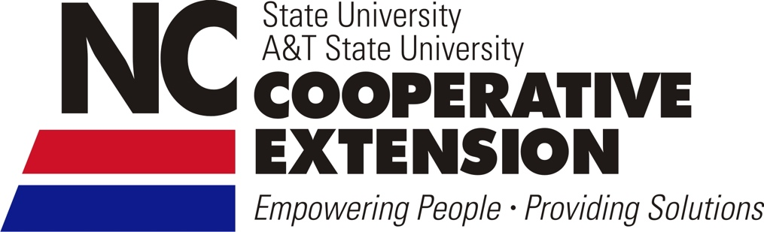

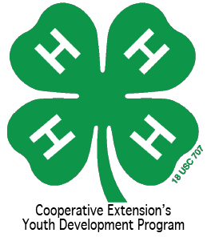

North Carolina State University and North Carolina A&T State University commit themselves to positive action to secure equal opportunity regardless of race, color, creed, national origin, religion, sex, age, veteran status or disability. In addition, the two Universities welcome all persons without regard to sexual orientation. North Carolina State University, North Carolina A&T State University, U.S. Department of Agriculture, and local governments cooperating.

